Sigurjón Ólafsson HBV501G Verkefni 2 [sio43@hi.is](mailto:sio43@hi.is)

**MVC pattern**

**Model:** Entity Database

**View:** HTML

**Contolller: Controlers – services**

**Models:** Customer

**View:** HTML, JSP Templating engine

**Contollers:**

**Routing controllers:**

Login Controller

**Services**

Loginservice<I>

LoginServiceImpl

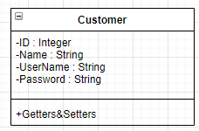

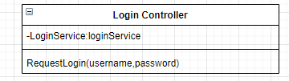

@RequestMapping (‘/Login’, Method=POST);

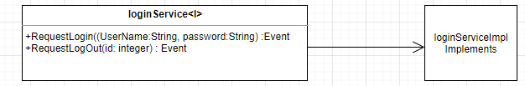

Sequence Diagram for User Login

